Murilo dos Santos Barbosa – Arquitetura Computacional – SPTECH

Exercícios Portas Lógicas

**1) Dado o circuito abaixo faça a tabela verdade e a expressão booleana**

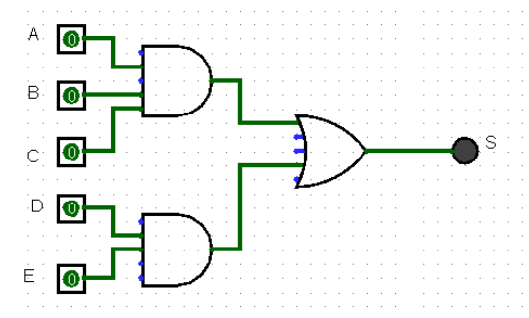

**Expressão booleana:**

S = (A B C) + (D E)

**Tabela Verdade:**

|  |  |  |  |  |  |
| --- | --- | --- | --- | --- | --- |
| **A** | **B** | **C** | **D** | **E** | **S** |
| 0 | 0 | 0 | 0 | 0 | 0 |
| 0 | 0 | 0 | 0 | 1 | 0 |
| 0 | 0 | 0 | 1 | 0 | 0 |
| 0 | 0 | 0 | 1 | 1 | 1 |
| 0 | 0 | 1 | 0 | 0 | 0 |
| 0 | 0 | 1 | 0 | 1 | 0 |
| 0 | 0 | 1 | 1 | 0 | 0 |
| 0 | 0 | 1 | 1 | 1 | 1 |
| 0 | 1 | 0 | 0 | 0 | 0 |
| 0 | 1 | 0 | 0 | 1 | 0 |
| 0 | 1 | 0 | 1 | 0 | 0 |
| 0 | 1 | 0 | 1 | 1 | 1 |
| 0 | 1 | 1 | 0 | 0 | 0 |
| 0 | 1 | 1 | 0 | 1 | 0 |
| 0 | 1 | 1 | 1 | 0 | 0 |
| 0 | 1 | 1 | 1 | 1 | 1 |
| 1 | 0 | 0 | 0 | 0 | 0 |
| 1 | 0 | 0 | 0 | 1 | 0 |
| 1 | 0 | 0 | 1 | 0 | 0 |
| 1 | 0 | 0 | 1 | 1 | 1 |
| 1 | 0 | 1 | 0 | 0 | 0 |
| 1 | 0 | 1 | 0 | 1 | 0 |
| 1 | 0 | 1 | 1 | 0 | 0 |
| 1 | 0 | 1 | 1 | 1 | 1 |
| 1 | 1 | 0 | 0 | 0 | 0 |
| 1 | 1 | 0 | 0 | 1 | 0 |
| 1 | 1 | 0 | 1 | 0 | 0 |
| 1 | 1 | 0 | 1 | 1 | 1 |
| 1 | 1 | 1 | 0 | 0 | 1 |
| 1 | 1 | 1 | 0 | 1 | 1 |
| 1 | 1 | 1 | 1 | 0 | 1 |
| 1 | 1 | 1 | 1 | 1 | 1 |

­­

**2) Dada a expressão boolena apresente o circuito e a tabela verdade:**

**S = (AB) + (CD) + (EF)**

Circuito:

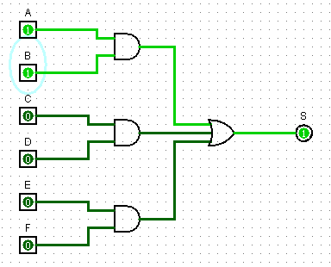

Tabela verdade:

|  |  |  |  |  |  |  |
| --- | --- | --- | --- | --- | --- | --- |
| **A** | **B** | **C** | **D** | **E** | **F** | **S** |
| 0 | 0 | 0 | 0 | 0 | 0 | 0 |
| 0 | 0 | 0 | 0 | 0 | 1 | 0 |
| 0 | 0 | 0 | 0 | 1 | 0 | 0 |
| 0 | 0 | 0 | 0 | 1 | 1 | 1 |
| 0 | 0 | 0 | 1 | 0 | 0 | 0 |
| 0 | 0 | 0 | 1 | 0 | 1 | 0 |
| 0 | 0 | 0 | 1 | 1 | 0 | 0 |
| 0 | 0 | 0 | 1 | 1 | 1 | 1 |
| 0 | 0 | 1 | 0 | 0 | 0 | 0 |
| 0 | 0 | 1 | 0 | 0 | 1 | 0 |
| 0 | 0 | 1 | 0 | 1 | 0 | 0 |
| 0 | 0 | 1 | 0 | 1 | 1 | 1 |
| 0 | 0 | 1 | 1 | 0 | 0 | 1 |
| 0 | 0 | 1 | 1 | 0 | 1 | 1 |
| 0 | 0 | 1 | 1 | 1 | 0 | 1 |
| 0 | 0 | 1 | 1 | 1 | 1 | 1 |
| 0 | 1 | 0 | 0 | 0 | 0 | 0 |
| 0 | 1 | 0 | 0 | 0 | 1 | 0 |
| 0 | 1 | 0 | 0 | 1 | 0 | 0 |
| 0 | 1 | 0 | 0 | 1 | 1 | 1 |
| 0 | 1 | 0 | 1 | 0 | 0 | 0 |
| 0 | 1 | 0 | 1 | 0 | 1 | 0 |
| 0 | 1 | 0 | 1 | 1 | 0 | 0 |
| 0 | 1 | 0 | 1 | 1 | 1 | 1 |
| 0 | 1 | 1 | 0 | 0 | 0 | 0 |
| 0 | 1 | 1 | 0 | 0 | 1 | 0 |
| 0 | 1 | 1 | 0 | 1 | 0 | 0 |
| 0 | 1 | 1 | 0 | 1 | 1 | 1 |
| 0 | 1 | 1 | 1 | 0 | 0 | 1 |
| 0 | 1 | 1 | 1 | 0 | 1 | 1 |
| 0 | 1 | 1 | 1 | 1 | 0 | 1 |
| 0 | 1 | 1 | 1 | 1 | 1 | 1 |
| 1 | 0 | 0 | 0 | 0 | 0 | 0 |
| 1 | 0 | 0 | 0 | 0 | 1 | 0 |
| 1 | 0 | 0 | 0 | 1 | 0 | 0 |
| 1 | 0 | 0 | 0 | 1 | 1 | 1 |
| 1 | 0 | 0 | 1 | 0 | 0 | 0 |
| 1 | 0 | 0 | 1 | 0 | 1 | 0 |
| 1 | 0 | 0 | 1 | 1 | 0 | 0 |
| 1 | 0 | 0 | 1 | 1 | 1 | 1 |
| 1 | 0 | 1 | 0 | 0 | 0 | 0 |
| 1 | 0 | 1 | 0 | 0 | 1 | 0 |
| 1 | 0 | 1 | 0 | 1 | 0 | 0 |
| 1 | 0 | 1 | 0 | 1 | 1 | 1 |
| 1 | 0 | 1 | 1 | 0 | 0 | 1 |
| 1 | 0 | 1 | 1 | 0 | 1 | 1 |
| 1 | 0 | 1 | 1 | 1 | 0 | 1 |
| 1 | 0 | 1 | 1 | 1 | 1 | 1 |
| 1 | 1 | 0 | 0 | 0 | 0 | 1 |
| 1 | 1 | 0 | 0 | 0 | 1 | 1 |
| 1 | 1 | 0 | 0 | 1 | 0 | 1 |
| 1 | 1 | 0 | 0 | 1 | 1 | 1 |
| 1 | 1 | 0 | 1 | 0 | 0 | 1 |
| 1 | 1 | 0 | 1 | 0 | 1 | 1 |
| 1 | 1 | 0 | 1 | 1 | 0 | 1 |
| 1 | 1 | 0 | 1 | 1 | 1 | 1 |
| 1 | 1 | 1 | 0 | 0 | 0 | 1 |
| 1 | 1 | 1 | 0 | 0 | 1 | 1 |
| 1 | 1 | 1 | 0 | 1 | 0 | 1 |
| 1 | 1 | 1 | 0 | 1 | 1 | 1 |
| 1 | 1 | 1 | 1 | 0 | 0 | 1 |
| 1 | 1 | 1 | 1 | 0 | 1 | 1 |
| 1 | 1 | 1 | 1 | 1 | 0 | 1 |
| 1 | 1 | 1 | 1 | 1 | 1 | 1 |

**3) Dada a tabela verdade a seguir, desenhe o seu circuito lógico e a expressão booleana**

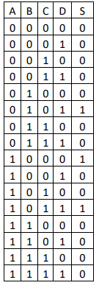

Expressão booleana:



Circuito Lógico:

